**Guide to Reloading the Scripts**

Remove the four screws holding the faceplate of the electrical box.

There is a “SanDisk” USB memory stick and “Amazon Basic USB Hub” Velcroed in the black electrical box.

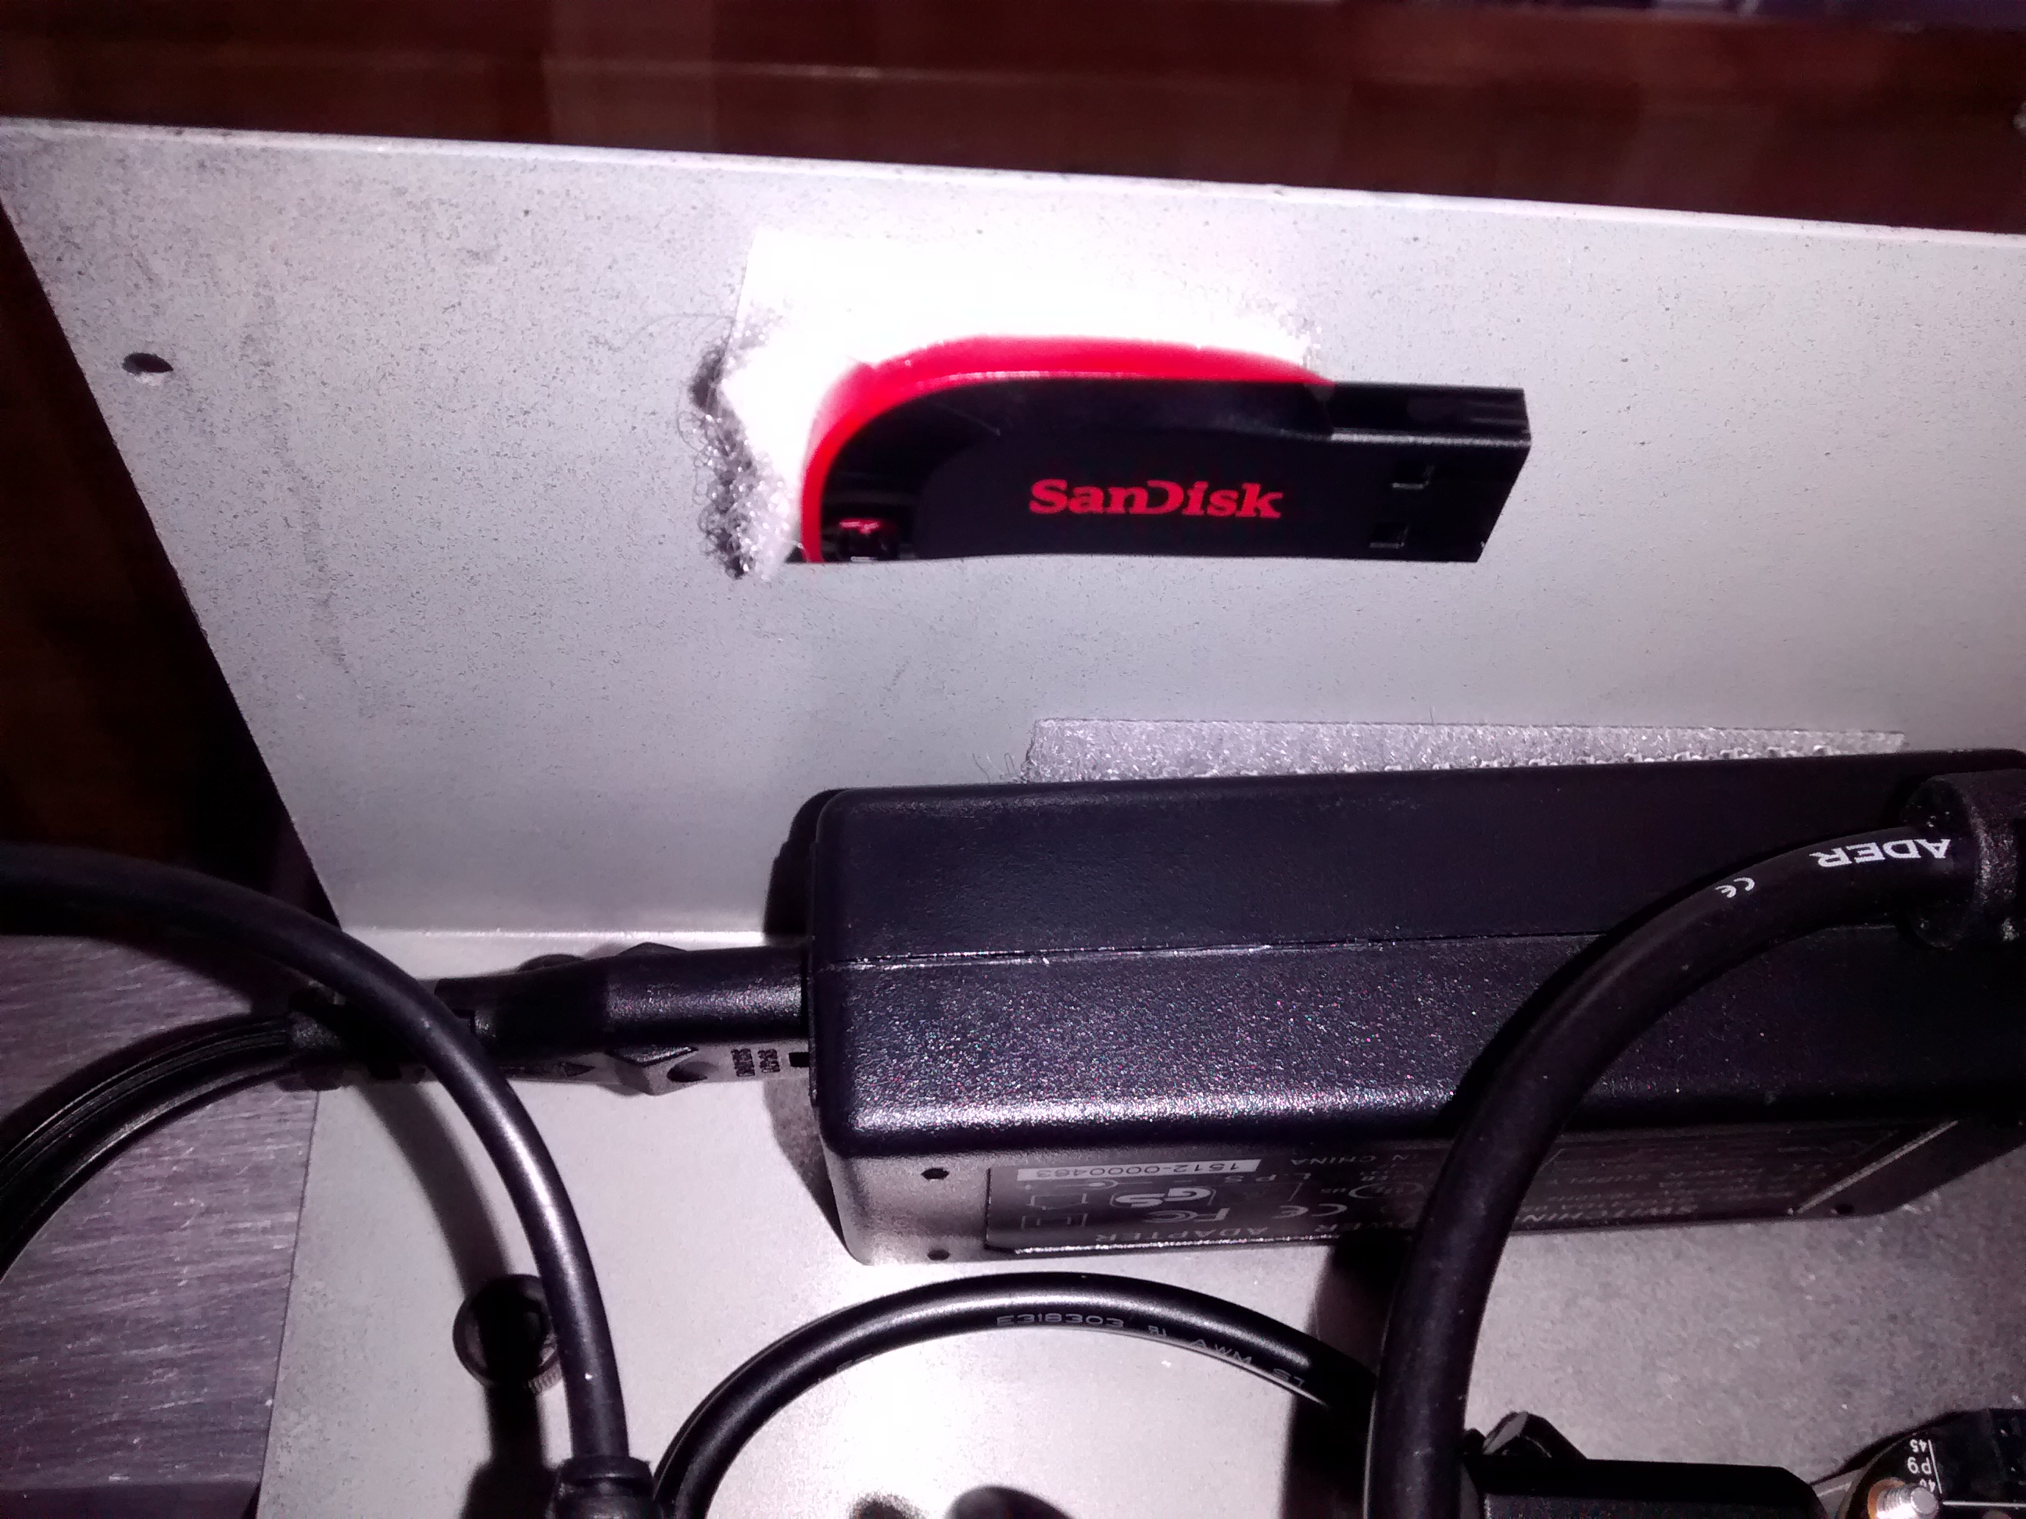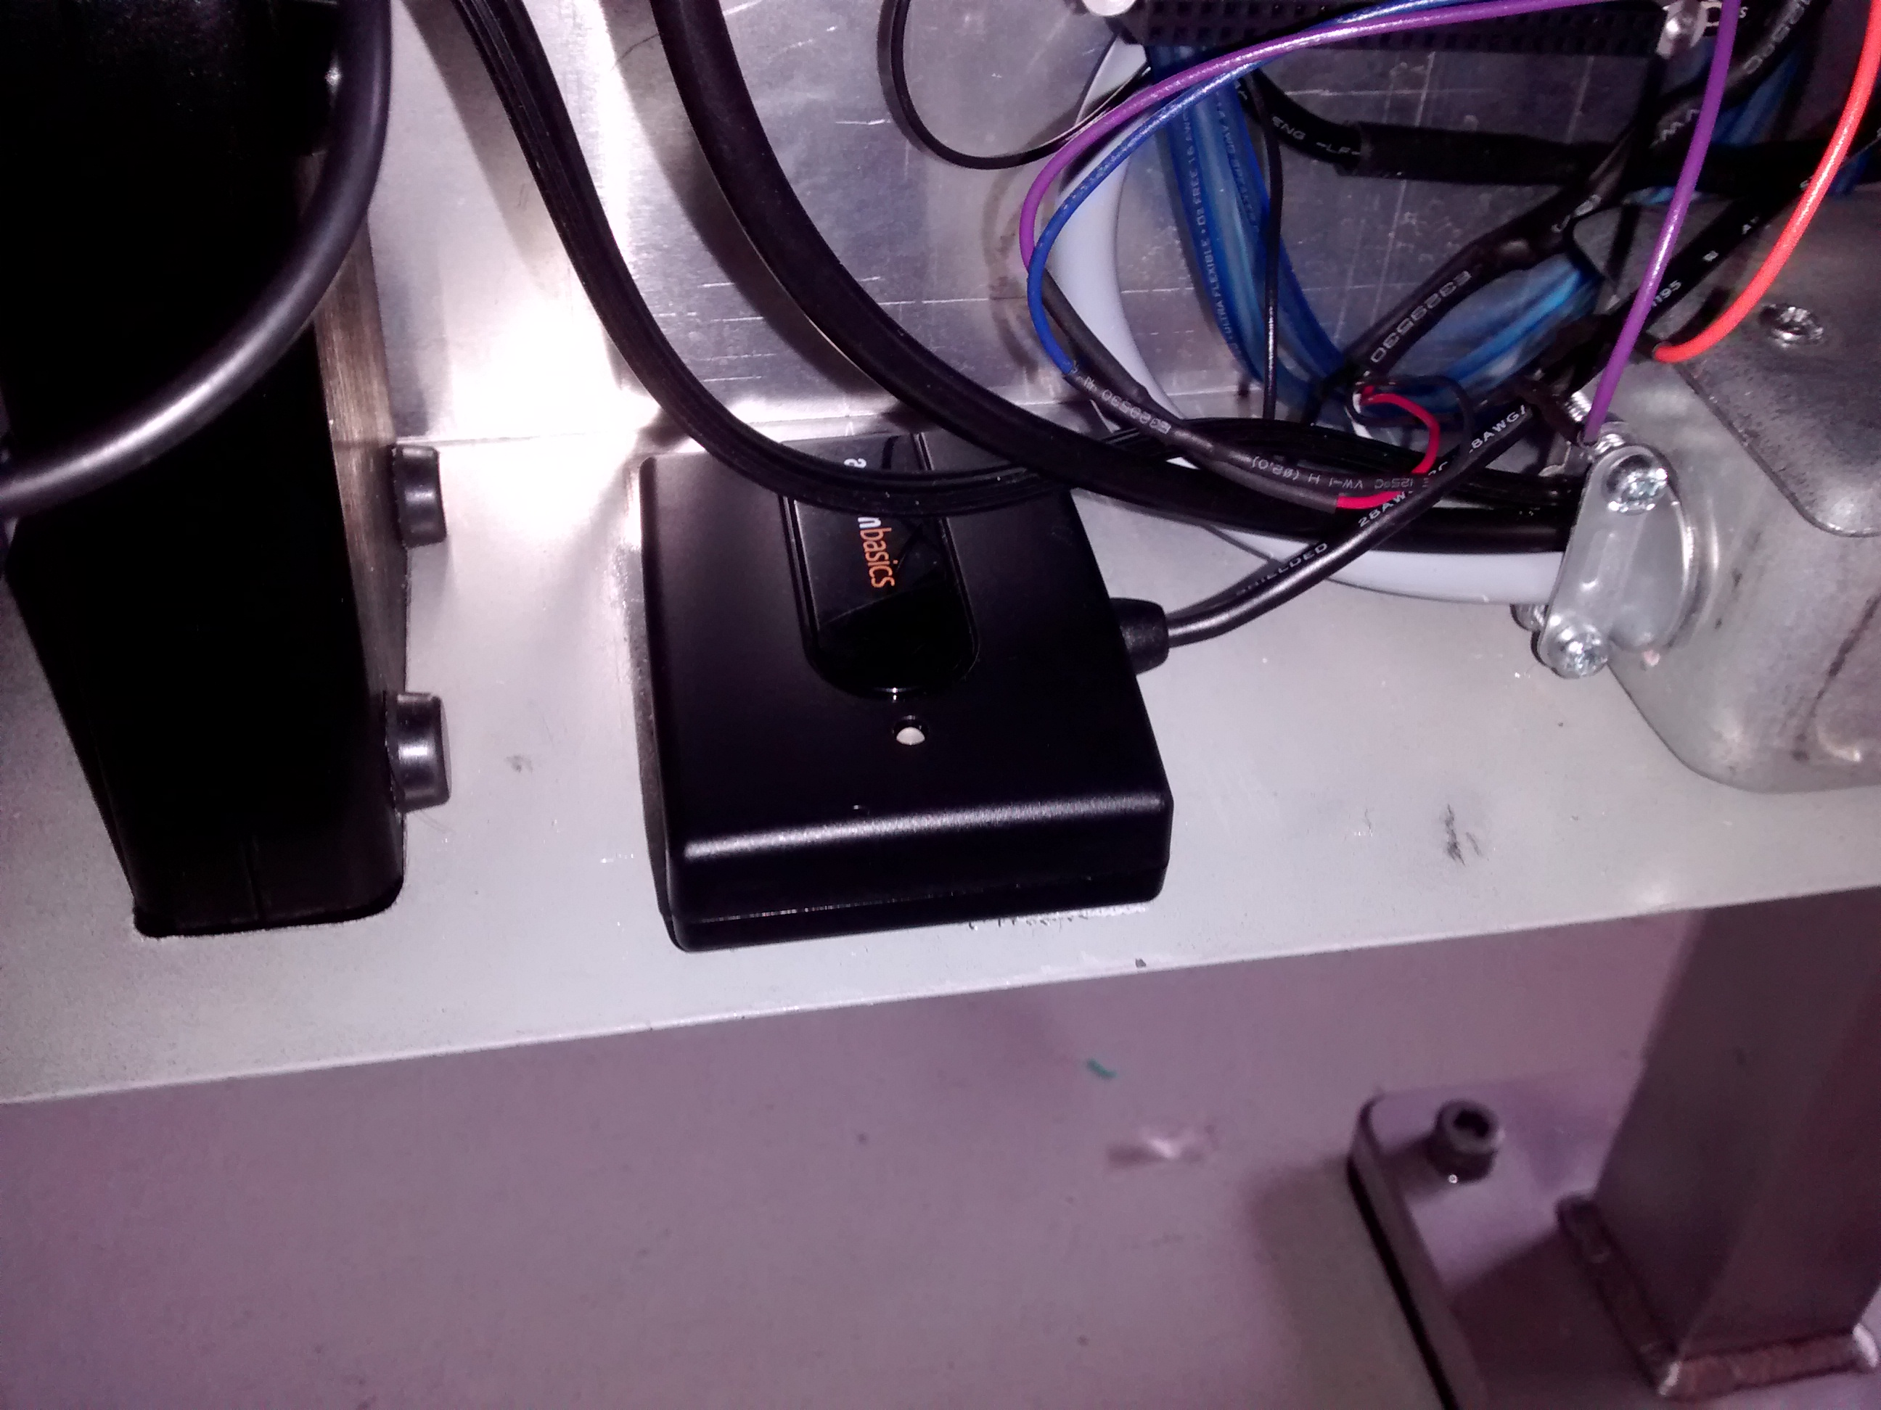

1. Remove the USB audio card from the USB port on the black PC board. 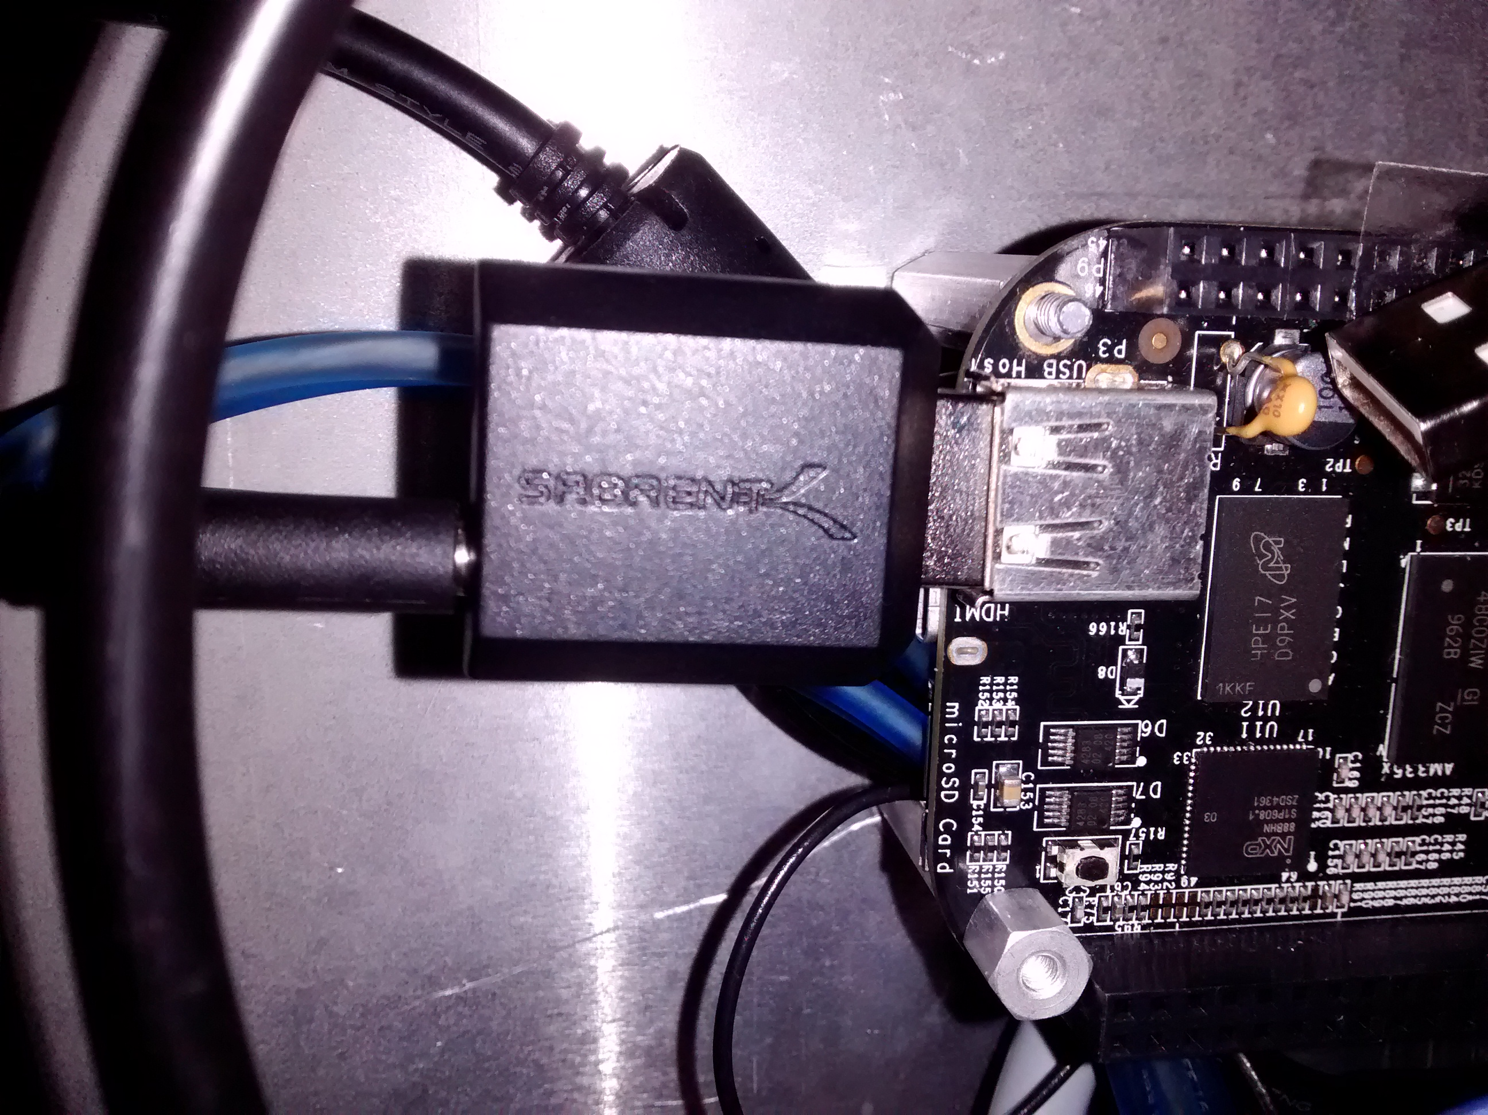
2. Inset the USB memory stick and the USB audio card into the USB Hub.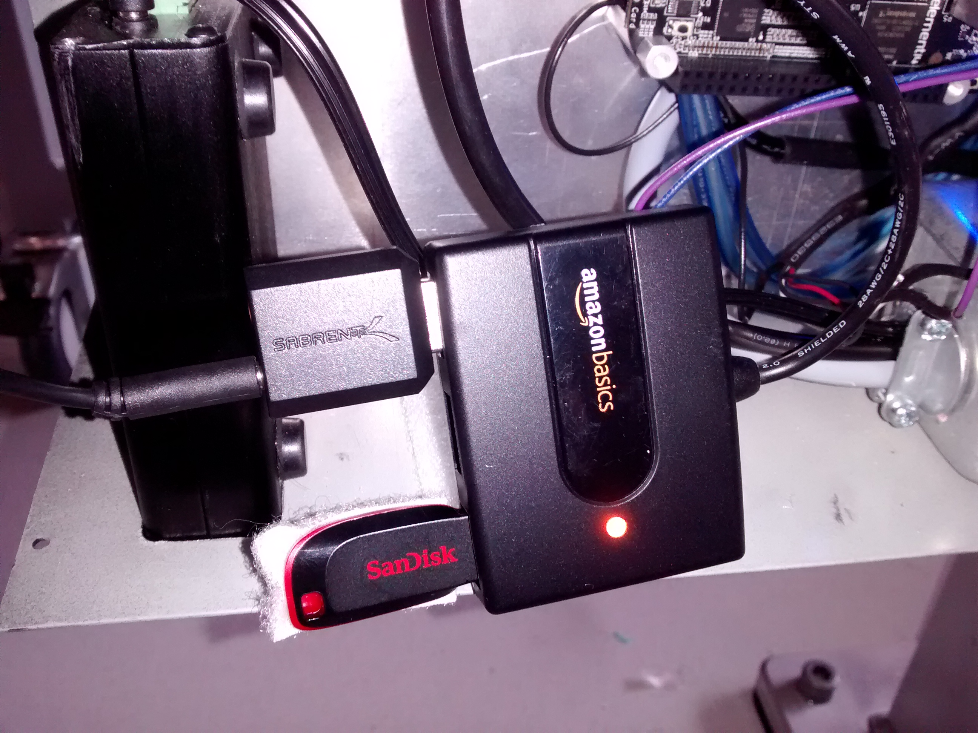
3. Switch off the power to the system
4. Insert the USB hub’s USB cable into the beagle bone black
5. Turn on system
6. Wait until the system instructs you to remove the USB memory device. Disconnect the USB hub from the Beagle bone and the reconnect the USB sound card to the beagle bone’s USB port.
7. Switch the system off, count to 10 then switch it back on. The new audio scripts are now loaded into the system.
8. Reattach the faceplate to the electrical box

Note 1: In the event that you leave the USB audio card connected to the USB hub without the USB memory device attached to the hub, the next time the system restarts the USB audio card will not function (This is a “bug” in the beagle bone black’s OS, an issue the manufacturer did not chose to solve)

Note 2: Only the USB memory stick included with this project will work with this procedure. In the event that the USB memory device no longer functions, an individual with basic Linux skills (such as a computer IT employee or a upper level computer engineering/computer scientist/IT student from Oakland University) could download new scripts to the Beaglebone black through it’s mini-usb port. There are instructions available online on how to install the necessary USB drivers for the Beagle bone black and the audio MP3 scripts are located at ~/software/audio.